**Mr SGs Waves notes**

**Oscillations (vibrations)**

-Many objects in nature will vibrate or oscillate, moving around their average position in a regular, repetitive or periodic manner

-Examples of oscillating objects include a mass on a spring bouncing up and down, a pendulum swinging back and forward or atoms in a solid oscillating around their mean position in the solid lattice

-A graph showing the displacement of an oscillating object over time produces a sinusoidal curve

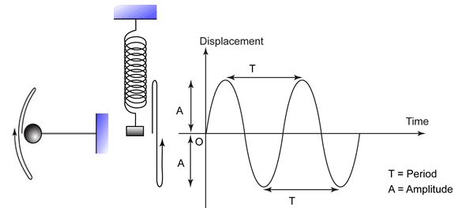

-An oscillating objects maximum displacement is known as it’s amplitude (A)

-The time taken to complete one oscillation is known as it’s period (T)

**Waves**

-Oscillating objects can act as the source for waves

-A wave is something that transfers energy from one point to another without the transfer of matter

-Waves involve the oscillations of particles or fields, with the oscillations transferring energy to neighbouring particles or regions

-The relationship between oscillations and waves can be seen by holding a string or a slinky that is fixed at one end

-If the end of the slinky is moved in a single up and down motion, this will create a single wave pulse

-As each part of the slinky travels upwards, it exerts a force on adjacent parts of the slinky, causing the up and down motion (the wave pulse) to travel along the slinky

-The wave pulse transfers energy from the source to the other end of the slinky without the transfer of matter

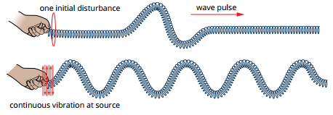

-If the end of the slinky is continuously oscillated up and down, it will create a travelling wave that moves through the slinky

**Classification of Waves**

-Waves can be classified based on whether they require a medium and whether or not the oscillations occur parallel or perpendicular to the direction of travel of the wave

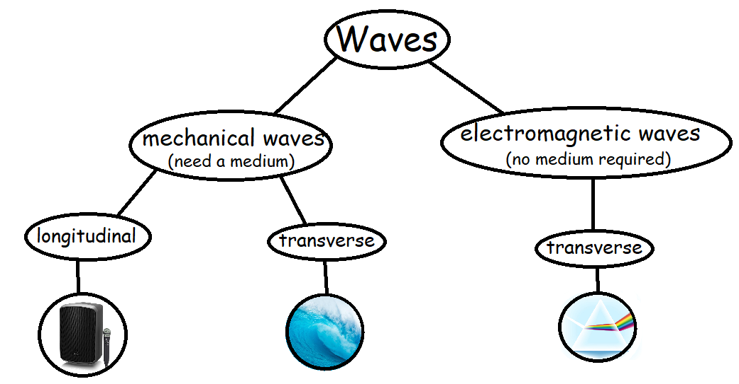

**Mechanical waves**: waves that require a medium to transmit energy

-Water waves, sound waves and waves in strings and springs are all mechanical waves

**Electromagnetic waves:** waves that do not require a medium to transmit energy

-Visible light, gamma rays and radio waves are all electromagnetic waves

-We will study mechanical waves in Year 11 and electromagnetic waves in Year 12

**Transverse waves:** waves where the particles in the medium (or the fields in an electromagnetic wave) oscillate at right angles to the direction of wave travel

-Water waves, waves in strings and electromagnetic waves are examples of transverse waves

-In transverse waves, crests and troughs can be observed moving in the direction of wave travel



**Crest**: an area of maximum positive displacement (x = +A)

**Trough:** an area of maximum negative displacement (x = -A)

-While the troughs and crests appear to travel along the medium, individual particles oscillate at right angles to the direction of wave travel

**Longitudinal waves:** waves where the particles in the medium oscillate back and forward in the same plane as the wave travels

**-**Sound waves and waves in springs are examples of longitudinal waves



-Longitudinal waves do not have crests and troughs

-As the backwards and forwards oscillations propagate through the medium, particles bunch together in some regions and spread apart in others

**Compression**: an area where particles of the medium are bunched together

**Rarefaction**: an area where particles in the medium are spread apart

-These compressions and rarefactions can be observed moving in the direction of wave travel

**Sound waves**

-Sound waves are a type of longitudinal wave that is produced when a vibrating object causes air molecules to oscillate

-The vibrations cause regions of air to become compressed (compressions) and other regions to become spread out (rarefactions).

-These travel outwards from the source as a sound wave (similar to ripples moving outwards from a stone dropped in water)

-Note that while the wave travels outwards, the air molecules themselves do not, instead oscillating (moving back and forward) around a fixed position

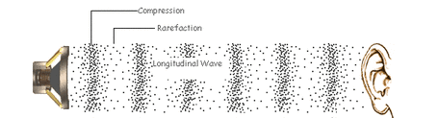

-Sound waves are sometimes called pressure waves as the compressions are areas of high pressure and the rarefactions are areas of low pressure

-Sound waves can be visualised by plotting how air pressure varies with distance from the source of the wave

-The plot takes the form of a transverse wave, with compressions becoming crests and rarefactions becoming troughs



**Representing waves**

**Displacement-distance graphs**

-Transverse waves can be represented by plotting a displacement-distance graph showing the displacement of particles (from their mean position) as the distance from the wave source increases

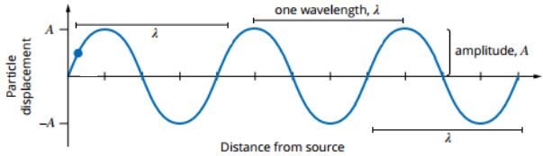

-A displacement-distance graph can be used to determine a wave’s:

**Amplitude (A):** The maximum displacement of a particle from its mean position

**Wavelength (λ):** The distance between any two successive points of the wave that are in phase (where particles have the same displacement and are moving in the same direction), such as successive peaks or successive troughs

**Displacement-time graphs**

-Waves (and oscillations) can also be represented by displacement-time graphs showing the displacement of a single particle over time

-While these graphs look very similar to displacement-distance graphs, they give us other information about a wave

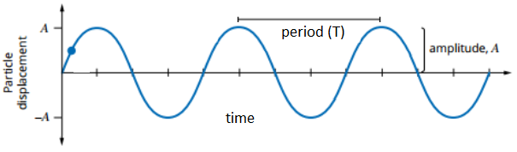

-A displacement-time graph can be used to determine a wave’s:

**Period (T):** The time interval for one complete wave cycle to occur

**Frequency (f)**: The number of wave cycles that occur each second (this can be calculated from the period)

-Frequency has units of hertz (Hz), where 1 Hz is equal to 1 cycle per second

**f = 1** where f is frequency (Hz) and T is period (s)

**T**

**The wave equation**

-These wave characteristics can be used to measure the speed of a wave

-Speed is calculated by: **v = d** where v is speed (ms-1), d is distance (m) and

**t** t is time (s)

-For a wave that travels a distance equal to its wavelength each period:

**v = λ** where λ is wavelength (m) and T is period (s)

**T**

-As frequency is calculated by: **f = 1** the equation can be written as:

**T**

**v = fλ** where v is speed (ms-1), f is frequency (Hz) and λ is wavelength (m)

**Wave behaviours**



-When a wave changes medium, the energy carried by the wave can be reflected, transmitted, absorbed, or some combination of these processes

-In the image to the right, the reflection of the cat shows light being reflected, while the image from outside the window shows light being transmitted

-The absorption of light could be detected by a temperature increase of the glass

-The degree of which a wave is reflected, transmitted or absorbed depends on how similar the properties of the two mediums are

**Reflection (1-D)**

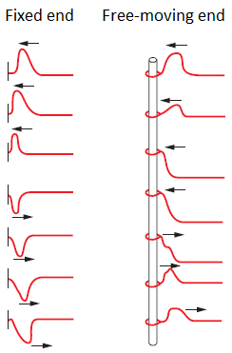

-When a wave strikes an obstacle or comes to the end of its medium, at least part of the wave will be reflected

-When a wave pulse hits a fixed boundary, the reflected pulse is inverted (crests are reflected as troughs and vice versa)

-This inversion can be described as a phase shift of 180º or λ/2

-When a wave pulse hits a free boundary, it is reflected with no change of phase

-When a transverse wave is reflected, the amplitude of the reflected wave will be slightly reduced due to the absorption of energy by the material at the boundary

-Reflection, transmission and absorption will all occur to some degree when a wave’s medium changes

-The greater the increase in density from the first medium to the second, the more reflection and the less absorption will occur

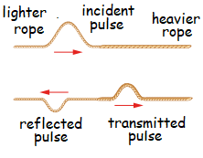

-This can be seen from the behaviour of wave pulses in a rope made by joining a lighter (less dense) rope to a heavier (denser) rope

-As wave pulse travels from the lighter rope to the heavier rope, part of the energy from the wave pulse is reflected (due to the increase in density) and part of the energy is transmitted

-This produces a transmitted pulse and a reflected pulse, both of which have a smaller amplitude than the incident pulse

**Wave fronts & rays**

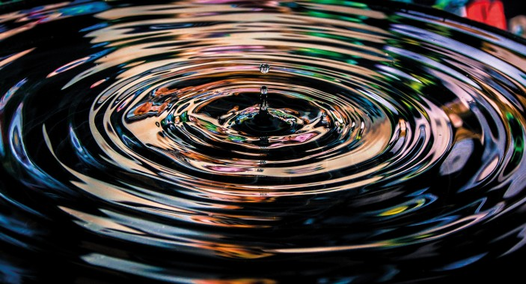

-When a stone is dropped into a pond, ripples will radiate out in all directions

-These ripples are the crests of the 2-dimensional wave generated by the stone

**Wave front**: a continuous portion of a 2-D or 3-D wave where the particles are moving in the same direction at the same time

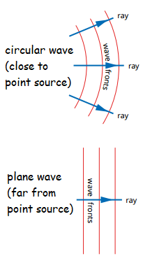

-The points along each spherical crest of the water wave above represent a wave front

-Wave fronts are highly curved close to a point source, but they become less curved as the distance from the source increases

-The direction of travel of a wave front can be shown with a ray, a line perpendicular to the wave front with an arrowhead showing the direction of motion

-When considering how waves (including light and sound) are reflected or refracted, it is more useful to consider the behaviour of rays than wave fronts

**The ray model of reflection**

-We can use the ray model to study how waves reflect off surfaces



Terminology:

-**incident ray**: the ray travelling towards the reflective surface

-**reflected ray**: the ray that has reflected off the surface

-**normal**: an imaginary line at 90º from the reflective surface

-**angle of incidence** (θi): the angle between the incident ray and the normal

-**angle of reflection** (θr): the angle between the reflected ray and the normal

-The law of reflection states that the angle of incidence is equal to the angle of reflection

**θi = θr**

-Reflection can be regular or diffuse, depending on the nature of the reflective surface

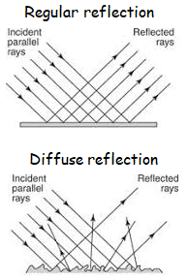

-Regular reflection occurs when rays strike a smooth, flat surface so that all rays have the same angles of incidence and reflection and the reflected rays will remain parallel to each other

-Diffuse reflection occurs when rays strike an irregular surface, so that rays will strike the surface with different angles of incidence and reflection and the reflected rays will no longer be parallel

**Echoes & reverberation**

-Echoes and reverberation are both phenomena caused by the (regular) reflection of sound waves causing

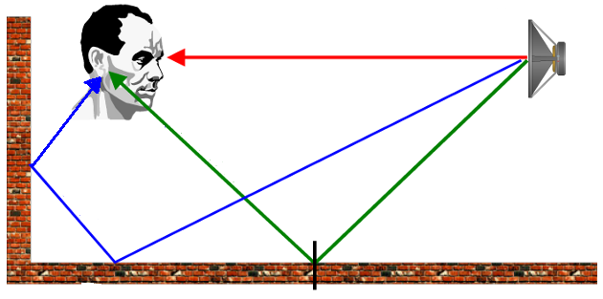

-The red ray above represents the most direct path between a sound wave and the listener, whereas the green and blue waves represent longer reflected paths

-Reflected sound waves travelling along the blue and green paths reach the listener after sound waves travelling along the direct path

-If the reflected wave reaches the listener 0.1 s or later after the direct wave, it will be heard as an echo (a distinct second sound)

-If it reaches the listener less than 0.1 s later than the direct wave it will be heard as reverberation (the sound will appear to be longer lasting)

**Refraction**

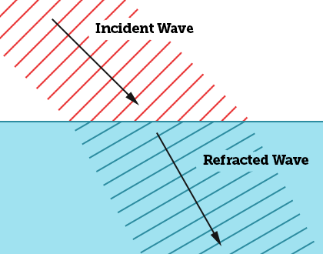

-The speed of a wave (including sound waves) depends on the medium in which it is travelling

-Sound travels faster in solids than in liquids and gases due to the greater elasticity of solid mediums

-Sound travels more slowly in a denser material of a given elasticity

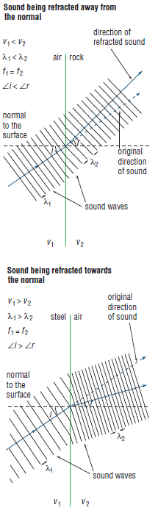

-Whenever a wave changes medium at an angle to the normal, the wave will be bent (refracted)

-This is because the section of each wavefront entering the new medium will change speed, while the rest of the wavefront is still travelling at its initial speed (until it too enters the second medium)

-The wave will bend while different parts of each wavefront are travelling at different speeds, similar to how a car will veer to the left if its left wheels leave the road into sand

Terminology:

-**incident ray**: the ray travelling towards the change of medium

-**refracted ray**: the ray that has been refracted and is travelling away from the change of medium

-**normal**: an imaginary line at 90º from the change of medium

-**angle of incidence** (i): the angle between the incident ray and the normal

-**angle of refraction** (r): the angle between the reflected ray and the normal

-Refraction changes the speed of a wave and its wavelength, but it does not affect its frequency

-When a wave slows down (v1 > v2), its wavelength decreases and it bends towards the normal

-When a wave speeds up (v2 > v1), its wavelength increases and it bends away from the normal

-The relationship between the angles of incidence and refraction, wave speed and wavelength is expressed in Snell’s Law:

**sin r = v2 =  λ2**

**sin i v1 λ1**

-Whenever refraction occurs, some of the wave is also reflected

**Total internal reflection**

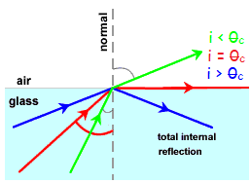

-When a wave moves into a medium where its speed increases, it bends away from the normal

-As the angle of incidence increases, so does the angle of refraction

-Eventually, when the angle of incidence is large enough, the refracted ray will be refracted along the interface of the two materials (e.g. the angle of refraction will be 90º)

-This angle is called the critical angle (θc)

-When the angle of incidence is greater than the critical angle, total internal reflection will occur, where all waves are reflected back into the medium

**sin r = v2**

**sin i v1**

-The formula for calculating the critical angle can be derived from Snell’s Law

-As is the critical angle, r = 90 º at the critical angle and sin 90 = 1, the expression becomes:

**Θc = sin-1 (v1/v2)**

-If a material allows a wave to travel significantly faster than the material it is initially travelling in (e.g. v2 >> v1), the critical angle will be very small, so the vast majority of waves striking the surface will be reflected

-Substances that are good insulators of sound are those that allow sound to travel much faster than air, thus decreasing the critical angle and reflecting most sound waves

**Seismic waves**

-Seismic waves are mechanical waves that travel through the earth following events such as earthquakes

**P (primary) waves**: fast travelling, longitudinal waves that can travel through solids and liquids

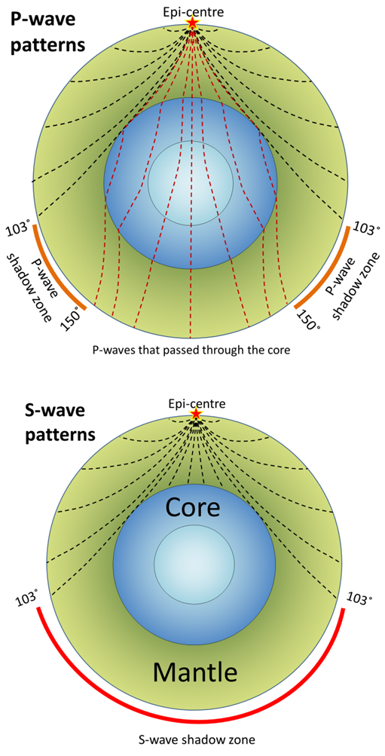

**S (secondary) waves**: slower travelling, more energetic, transverse waves that can only travel through solids

-The liquid structure of the earth’s outer core can be determined by observing how P-waves are reflected and S-waves are blocked by this region

**Diffraction**

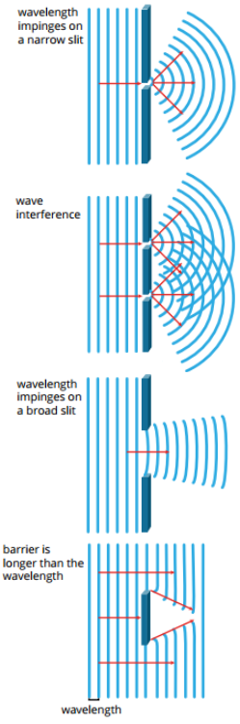

-It is possible to hear someone speak from around a corner, even when there are no surfaces that can reflect the sound

-This ability for waves to bend as they pass the edge(s) of an object is called diffraction

-The degree of diffraction depends on the wavelength of the wave and the size of the opening

-This causes lower frequency sounds to be diffracted more readily than higher frequency sounds

-Significant diffraction occurs when the wavelength of the wave is the same order of magnitude or larger than the width of the obstacle or aperture (gap)

**Doppler effect**

-The Doppler effect is a wave phenomenon that occurs when the source of a wave and the observer of the wave are moving relative to one another

-The actual frequency of the wave does not change, but the apparent frequency does

-When the source is moving towards the observer, each compression is emitted from a position closer to the observer than the last, causing the effective wavelength to decrease and the effective frequency to increase

-When the source is moving away from the observer, each compression is emitted from a position further away from the observer than the last, causing the effective wavelength to increase and the effective frequency to decrease

-This can be heard when an ambulance or police car is driving past you

-The sound of the siren is higher pitched as it is moving towards you and lower pitched as it is moving away

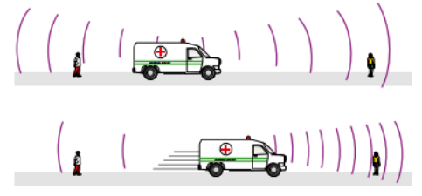

**Wave interactions**

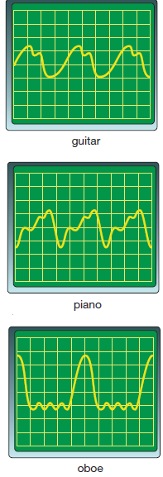

**Superposition & interference**

-When an oscilloscope is used to visualise the sounds produced by different instruments, the waveforms are more complicated than the sine wave produced by a single tone

-These complex wave forms are caused by the interactions of multiple waves with different frequencies and amplitudes

-When two wave pulses are travelling in opposite directions in a string, their crests will overlap at one moment in time

-At this point, the amplitude of the wave will increase as the crests overlap, before the initial pulses move past one another

-If the second wave pulse was a trough rather than a crest, the two pulses would partially cancel each other as the pulses overlapped

**Superposition:** When two or more waves travel in a medium, the resulting wave at any moment is the sum of the displacements associated with the individual waves

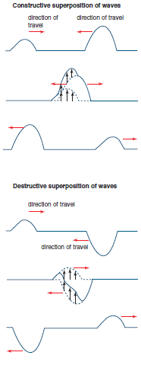

**Interference:** The combination or superposition of two or more waves

**Constructive Interference:** When two or more waves superpose to reinforce each other (where the displacement of the waves is in the same direction)

**Destructive Interference:** When two or more waves superpose to diminish each other (where the displacement of the waves is in opposite directions)

-The same note played on different musical instruments will sound different as the sound wave produced by an instrument will be formed by the superposition of the different frequencies generated by that instrument

-When two waves of identical amplitude and wavelength are completely in phase (all crests are aligned), **complete constructive interference** will occur, producing a wave with the same wavelength as the initial waves, but double the amplitude

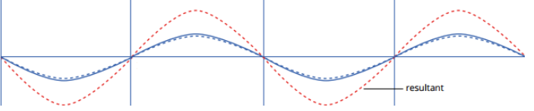

-When two waves of identical amplitude and wavelength are exactly opposite in phase (λ/2 out of phase), the peaks of one wave will coincide with the troughs in the other and **complete destructive interference** will occur with the waves producing a superposition of zero displacement

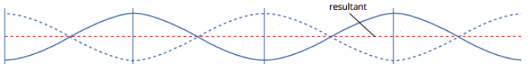

-One application of this is in “humbucking” guitar pickups



-Traditional guitar pickups consist of a coil of wire would around a magnet several times

-When the strings vibrate, they alter the magnetic field inducing a current in the coils that can be turned into sound waves by the speaker connected to the guitar

-Under some circumstances, guitar pickups can pick up radio and electrical interference, resulting in an unwanted ‘humming’ noise

-“Humbucker” pickups consist of two coils, wound in opposite directions around magnets of opposite polarity

-The ‘hum’ noise produced by the first coil will be completely out of phase to the ‘hum’ produced by the second coil, causing complete destructive interference between the two waves, eliminating the ‘hum’

-Constructive and destructive interference can also be observed by studying ‘beats’

-Beats are pulsations in volume that occur when two sounds of identical amplitude but slightly different frequency are produced

-The slight difference in frequency results in the waves moving in and out of phase in a regular manner

-When the sounds are in phase, constructive interference increases the amplitude (volume) of the sound and when they are out of phase, destructive interference decreases the volume

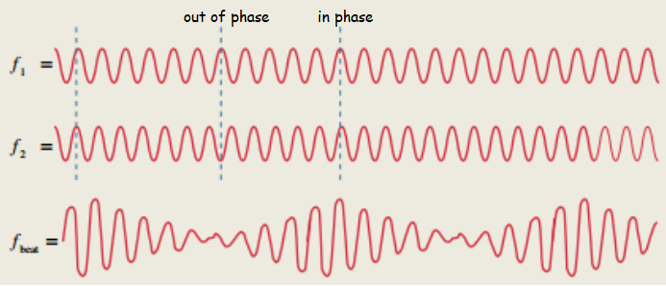

-The frequency of the beat can be calculated by: **fbeat = f2 – f1**

**Resonance**

-Many objects have a ‘resonant frequency’ (natural frequency) that they will vibrate at when forced to vibrate

-When an object is exposed to vibrations at this natural frequency, it will be forced to vibrate (resonate)

-Resonance can be seen by striking a tuning fork and holding it near other tuning forks

-The second fork will only start to resonate if its resonant frequency is the same as the forcing frequency (i.e. if it produces the same note)

-When the forcing frequency matches the resonant frequency of an object the amplitude of the oscillations in the resonant object increase dramatically and the energy transfer from the source of the forcing frequency to the resonant object is maximised

-It is possible to shatter a wine glass by exposing it to its resonant frequency <https://www.youtube.com/watch?v=lr9pmYdcfQY>

-Resonance is often desirable in musical instruments, for example the sound boxes of stringed instruments are designed to resonate at the range of frequencies produced by the instrument, making the instrument louder

-Resonance is generally undesirable in mechanical systems, where vibration at an objects resonance frequency wan cause it to vibrate with increasing amplitude until it destroys itself

-When soldiers cross a bridge, they will stop marching in unison as this can cause the bridge to resonate if its resonant frequency matches the forcing frequency of their footsteps

**Standing Waves & Harmonics**

**Standing waves in strings**

-When a wave pulse reaches the fixed end of a string, it is reflected back in the other direction 180º out of phase

-If a string is oscillated, the resulting waves will reflect back and forward along the string

-For waves of most wavelengths, the reflected waves will interfere in a completely random way and the waves will quickly decay

-For certain waves with a very specific wavelength, the reflected wave will interfere with the wave travelling in the opposite direction to produce a single standing wave with a greater amplitude

-It is called a standing wave as the wave does not visibly appear to travel along the string from one end to another (the string will instead oscillate up and down)

-As the two waves move past each other, they will alternate between being completely in phase and out of phase (double-click to play)



-There are points along the string called nodes (red dots in above gif) where complete destructive interference always occurs, and the displacement is always zero

-Successive nodes are located λ/2 apart

-At other points along the string (halfway between the nodes), the string oscillates with maximum amplitude

-These points called antinodes are where complete constructive interference occurs

-Successive antinodes are also located λ/2 apart

- The diagram to the right shows how the standing wave moves from complete constructive to complete destructive interference every ¼ T

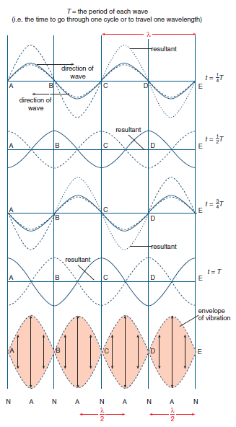

-Only waves of certain wavelengths can generate standing waves in this manner

-They will only occur at the natural frequencies of vibration (resonant frequencies) of their medium (e.g. the string)

-Three of the resonant frequencies of a rope are shown below

-As the ends of a string are both fixed, so there will always be nodes located at both ends



**Harmonics in strings**

-When a stringed instrument is plucked, a large number of waves with different frequencies and wavelengths will be generated and reflect back and forward from the fixed ends



-Most of these waves will interfere randomly and rapidly decay, but the resonant frequencies will form standing waves and remain

-The resonant frequencies produced are called harmonics

-The lowest frequency/longest wavelength with a single antinode is called the fundamental frequency or the first harmonic

-The higher frequency harmonics are called overtones (e.g. the second harmonic is the first overtone)

-The sound produced by a stringed instrument is produced by the combination of the harmonics produced

-The fundamental frequency has the largest impact on the sound produced as it has the largest amplitude

-The wavelengths the harmonics produced in a string are determined by the length of the string, allowing them to be calculated using:

**Λn = 2l** where λn is the wavelength of the nth harmonic (m), l is the

**n** length of the string (m) and n is the number of the harmonic

-As the frequency of a wave is determined by the velocity of the wave and its wavelength, the frequencies of the harmonics produced in a string can be calculated using:

**fn = nv = nf1** where fn is the frequency of the nth harmonic (Hz), l is the

**2l** length (m), v is the waves velocity (ms-1) and n is the number of the harmonic

-Stringed instruments are typically tuned by changing the string tension (but not length)

-Increasing the tension in a string increases the velocity of the waves in the string, causing the frequency to increase without affecting the wavelength

**Standing waves in air columns**

-The sounds of wind instruments are caused by the longitudinal standing waves they produce

-The compressions and rarefactions of longitudinal sound waves will reflect from the open or closed ends of a pipe, similar to how transverse wave reflect from the ends of strings

-Sound waves reaching the open end of a pipe will reflect with a 180º change of phase (compressions are reflected as rarefactions and vice versa) like the fixed end of a string

-Sound waves reflecting from the closed end of a pipe will reflect with no change of phase (compressions are reflected as compressions and rarefactions as rarefactions)

-The gif below (double click to play) shows a longitudinal standing wave in a slinky

-In pipes, pressure nodes (areas of minimum pressure variation) are displacement antinodes (areas of maximum displacement variation) and vice versa



**Open pipes**

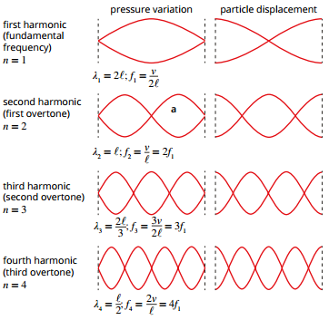

-Sound waves will reflect from the open end of a pipe with a 180º phase inversion (similar to waves in strings with fixed ends)

-To establish a standing wave in an open-ended pipe, a wave must have a wavelength that results in a pressure node (a displacement antinode) located at each end of the pipe, just like harmonics in strings have a node at each end

-This causes open pipes to have the same relationship between their length and the wavelength of their harmonics as in strings:

**Λn = 2l &**  **fn = nv = nf1**

**n 2l**

where λn is the wavelength of the nth harmonic (m), l is the length of the air column (m), n is the number of the harmonic, v is the waves velocity (ms-1) and fn is the frequency of the nth harmonic (Hz)

**Closed pipes**

-“Closed pipes” are pipes that have one closed end and one open end

-Sound waves reflect from the open end with a 180º phase inversion and from the closed end with no phase inversion

-To establish a standing wave in a closed pipe, a wave must have a wavelength that results in a pressure node (a displacement antinode) located at the open end of the pipe and a pressure antinode (a displacement node) at the closed end

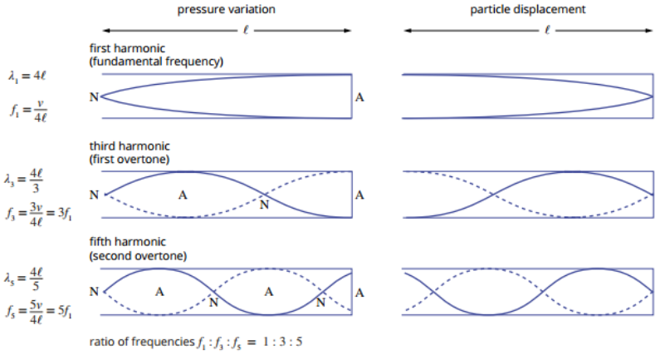

-The even numbered harmonics will not form for closed pipes, as they will not have a node at one end and an antinode at another

-The wavelengths and frequencies of the harmonics produced in a closed pipe can be calculated by:

**Λn = 4l &**  **fn = nv**_

**n 4l**

where λn is the wavelength of the nth harmonic (m), l is the length of the air column (m), n is the number of the harmonic **(odd numbered integers only)**, v is the waves velocity (ms-1) and fn is the frequency of the nth harmonic (Hz)

-On the data sheet, the formula for the harmonics is given as: **Λn = 4l**__

**(2n-1)**

where n is an integer that refers to the next harmonic in the sequence, NOT the harmonic number

**Wave Intensity**

-Waves carry energy from one point to another without transferring matter between those two points

-Intensity is a measure of the energy passing through each unit of area every unit of time

-It has units of Wm-2 (e.g. Joules per second per square metre)

-When a wave is emitted from a point source, will spread out spherically from the source

-As it spreads out, its intensity will decrease proportional to the square of its distance from the source

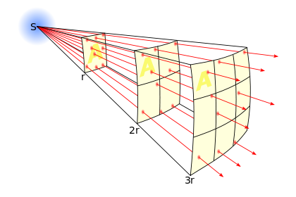

**I $∝$ 1** where I is intensity (Wm-2), and r is

**r2** the distance from the point source (m)

-This is an example of an “inverse square law”, a law that states that a physical quantity is inversely proportional to the square of the distance from the source of that quantity

**I1 = I2**

**r22 r12**

-When the intensity of a wave at some initial distance is known, its final intensity at a further distance can be calculated using the following formula, where I1 and I2 are intensity at distances r1 and r2

**Applications of Waves**

**Ultrasound**



-Humans can hear sounds with frequencies between approximately 20 – 20 000 Hz

-Ultrasound refers to frequencies of sound above 20 000 Hz

-Low intensity ultrasound can be used for imaging as the waves will refract and reflect when they move between body structures with different densities

-Ultrasound is used for imaging the foetus during pregnancy

-Higher intensity (≤ 30 000 Wm-2 for 5-10 mins) ultrasound can be used to produce heat in a localised area when treating sports injuries

-Even higher intensity (~100 000 Wm-2­) ultrasound can be used to rupture gallstones or to break cancer cells apart

**Acoustic engineering**

-Acoustic engineering uses the principles of wave motion to design spaces that will optimise the listening experience for people in those spaces

-In outdoor concert venues, the sound intensity decreases with the square of distance from the source

-In indoor venues, sounds can be reflected within the venue to prevent the intensity from decaying to the same extent

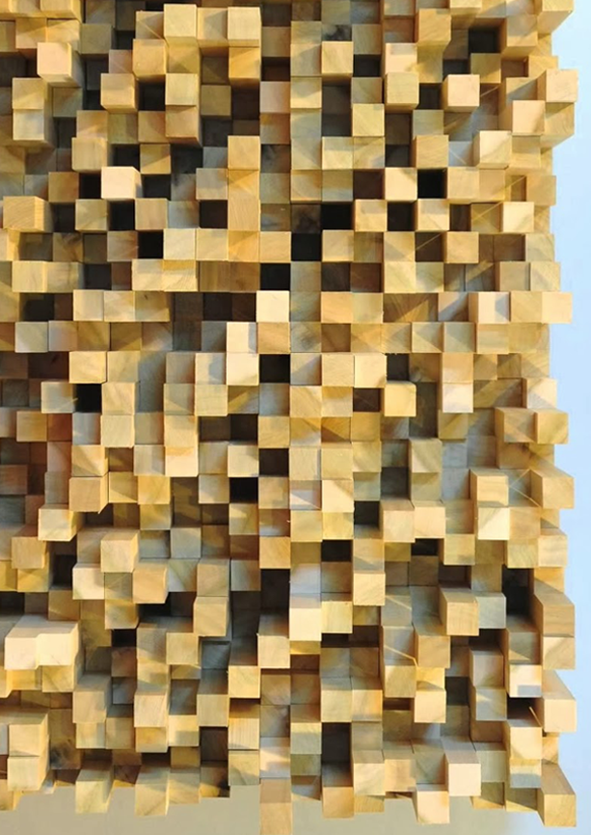

-Reflective surfaces within venues need to be designed to reflect sound waves in specific ways

-Hard flat surfaces can produce unwanted reverberations or echoes and can create standing waves that increase the volume of some frequencies

-Acoustic diffusers reflect and disperse sound in multiple directions, reflecting all frequencies so that the original (unreflected) sound is more faithfully reproduced

-Sound proofing uses reflection of sound waves and the use of sound absorbers to prevent the propagation of sound waves